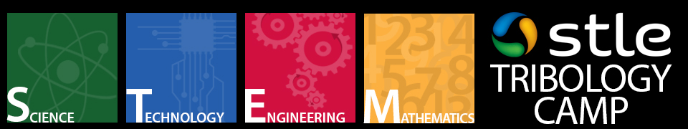

STLE 75th Annual Meeting & Exhibition
May 3-7, 2020
Hyatt Regency Chicago
Chicago, Illinois (USA)

Part I: Program Description
During STLE’s 2013 Annual Meeting & Exhibition in Detroit, Michigan, the society launched a successful new outreach program teaching high school students about tribology⎯the study of friction, lubrication and wear.

STLE’s goal is to introduce high school students, who have an interest in STEM (science, technology, engineering and mathematics), to career opportunities in tribology and lubrication engineering.

In an effort to help students and their teachers learn more about tribology, STLE is accepting proposals for experiments from STLE members and their organizations for the society’s Annual Tribology STEM Camp to be held as part of STLE’s 75th Annual Meeting & Exhibition, May 3-7, 2020, in Chicago, Illinois. We are requesting tribology or lubrication-related experiments and materials that are safe for high school students to run, as well as volunteers to help conduct the experiments, too.

Any ideas and write-ups of tribology or lubrication-related experiments would be welcomed for consideration. If you or your company are interested in participating in the STEM Camp, please complete the experiment application form and submit by January 20, 2020.

Questions? Please contact Karl Phipps, (847) 825-5536, kphipps@stle.org.

Part II: Experiment Application Form
*Please fill out the following information and submit to Karl Phipps, kphipps@stle.org by January 20, 2020.

Experiment Name:

Presenter(s) (Name and Job Title/Company):

Contact Person (Phone Number/Street Address/Fax/Email):

Experiment Description (25-50 word description abstract):

What type of equipment will you provide/bring for the experiment?

What type of utilities will be required for the experiment (electrical, water, etc?)

Experiment layout (How much space will you need? – Example: 2 Tables – 6 ft. each)

Additional support needed?

