FOR IN-PERSON ATTENDEES
KNOW BEFORE YOU GO: STLE Tribology and Lubrication for E-Mobility Conference, Nov. 3-5

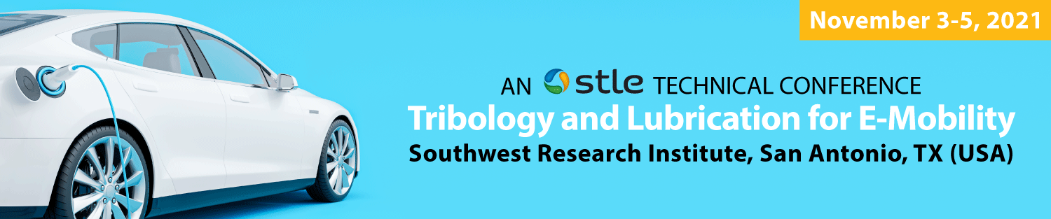

We’ll see you soon in San Antonio!

Dear Conference Attendees,

It’s almost time for the inaugural STLE Tribology and Lubrication for E-Mobility Conference, November 3-5, 2021, at the Southwest Research Institute (SwRI) in San Antonio, Texas. We look forward to your participation in the conference, which includes the optional EV education course program “Introduction to Electric Vehicles,” on Wednesday, November 3 from 8:30 am to 5 pm CT (advance registration required). Two days of technical sessions will be presented on Thursday, November 4 from 8:30 am to 5:15 pm US Central Time (CT) and 8:30 am to 1:00 pm CT on Friday, November 5, followed by a tour of the SwRI facility after the conference concludes.

We have included a few important details in advance of the conference to help you prepare.

Conference Venue
Southwest Research Institute (SwRI)
6220 Culebra Road
Bldg. 209 – Office of Automotive Engineering
San Antonio, TX 78238-5166

Attendees driving their own personal or rented vehicles will be required to provide their name and ID to security personnel at the SwRI entrance gate. Security will have a list of all in-person registered attendees allowed access on to the SwRI campus. Follow the directional signs to guide you to the correct building for the EV conference (B209 – Office of Automotive Engineering). Parking will be available near the conference building lot. The advanced registration area will be located on the third floor conference room of the Office of Automotive Engineering (B209). Click here for SwRI Driving Directions and Map.

Registration Schedule
Wednesday, November 3 (EV education course)
7:30 – 8:30 am
Registration and Continental Breakfast

Thursday, November 4 (EV technical sessions)
7:30 – 8:30 am
Registration and Continental Breakfast

Friday, November 5 (EV technical sessions)
7:30 – 8:30 am
Registration and Continental Breakfast

Airport Information
The Grand Hyatt San Antonio River Walk hotel is just 9 miles from the San Antonio International Airport. Taxi, limousine, van and shuttle services, ride-sharing services, and car rental companies all operate at the San Antonio International Airport. Please visit the airport website for additional ground transportation options.

Hotel Information
For hotel guests staying at the Grand Hyatt San Antonio River Walk, shuttle bus transportation will be provided by SwRI to and from the conference venue (Wednesday through Friday). Pick up is located at the Alteza/Ruth’s Chris entrance at the Grand Hyatt (look for directional signs in the elevator/lobby area for the buses). Pick up and departure times are as follows:

Wednesday, November 3
Hotel Pickup (Two buses) – 7:15 am
Departure from SwRI (Two buses) – 5:15 pm

Thursday, November 4
Hotel Pickup (Two buses) – 7:00 am
Departure from SwRI (Two buses) – 5:30 pm

Friday, November 5
Hotel Pickup (Two buses) – 7:00 am
Departure from SwRI (One bus) – 3:00 pm
Ride-Sharing Services
Uber and Lyft ride-sharing services are available in San Antonio, providing numerous travel options to get around throughout the city. Ride-share services are available to and from SwRI. Upon arrival, make sure to provide your name and ID to security personnel at the entrance gate if using these services. Security will have a list of registered attendees allowed access on to the SwRI campus. Free mobile apps are available for both services in the Apple (iOS) App Store and Android Apps in the Google Play Store.

Health & Safety
Our top priority remains the health and safety of all conference attendees, speakers and STLE staff attending the conference. All attendees will be required to follow established safety and health protocols, as STLE is working to ensure your participation is as safe as possible. SwRI requires all attendees be fully vaccinated and should refrain from entering SwRI if they are sick or self-monitoring for COVID-19 related symptoms. Masks, hand sanitizers and wiping stations will be available on-site for your use.
*Fully Vaccinated = 2 weeks following your second dose of Pfizer or Moderna vaccine or single dose of Johnson & Johnson vaccine.
Networking Events
There will be a special Meet-in-Greet scheduled for Wednesday, November 3 from 6:00 to 7:30 pm at the Grand Hyatt San Antonio River Walk. Come grab a drink at the cash bar and mingle with other attendees after the EV education course or engage with your colleagues checking in for the conference. In addition, a networking reception will be held on Thursday, November 4 from 6:30 to 8 pm at Biga on the Banks (www.biga.com), 203 South Mary’s at Market in downtown San Antonio, which is complimentary to all attendees, with food and drinks.

Technical Presentations and Session Recordings
For your convenience, we will be recording the entire conference. The final recording will include speakers who presented live as well as prerecorded presentations. All registered attendees will have access to the speaker presentation materials and recordings, which will be made available to you a few days after the conference concludes.
Click here to download the EV Conference Program Guide.
Click here to see who’s attending the conference.

If you have further questions, you can email STLE staff at information@stle.org or call (847) 825-5536.

Best regards,

The STLE Conference Team

Thank you to our Sponsors

Signature Event Sponsor

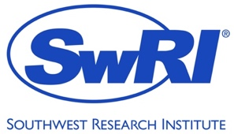

Power-Up Sponsors

Current Sponsors
